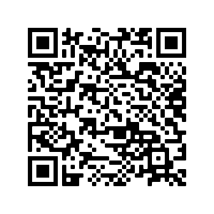
Tuesdays, starting October 17 10:30-11:15 You and your child from birth to age 3 are invited to join us for songs, rhymes and signs! Questions? Call the Mill Woods Branch at 780-496-1818 or email katie.bartee@epl.ca --- Space is limited. Registered spots are guaranteed until the class begins. Register for each class at epl.ca/ssll.
Scan to view all classes
SING, SIGN, LAUGH AND LEARN

Knottwood Community League
449 Knottwood Road West NW

Tuesdays, starting October 17
10:30-11:15
You and your child from birth to age 3 are invited to join us for songs, rhymes and signs!

Questions? Call the Mill Woods Branch at 780-496-1818 or email katie.bartee@epl.ca

Space is limited. Registered spots are guaranteed until the class begins.
Register for each class at epl.ca/ssll.

